SMART PRODUCT FINDING AND MANAGEMENT SYSTEM IN REAL TIME E-COMMERCE WEBSITE
ABSTRACT:
In the evolving landscape of retail, supermarkets aim to streamline and improve the shopping experience for customers. The integration of technology, specifically product finder systems, has emerged as a pivotal solution. This abstract explores the significance and impact of implementing product finder technology in supermarkets.Product finder systems leverage various technologies, such as mobile applications or in-store kiosks, to assist customers in locating items efficiently within the vast aisles of a supermarket. These systems utilize intuitive interfaces and database integration to provide real-time information about product locations, aisle numbers, pricing, and even personalized recommendations based on shopping history or preferences.
- INTRODUCTION
A product finder on a supermarket website is an intuitive tool designed to help users easily locate specific items within the store. Using search filters or categories, it simplifies the shopping experience by swiftly identifying the aisle or location where the desired products are stocked. This feature saves time, enhances convenience, and provides a seamless navigation experience for customers looking for particular items while shopping online or in-store.A product finder on a supermarket website is an intuitive tool designed to help users easily locate specific items within the store. Using 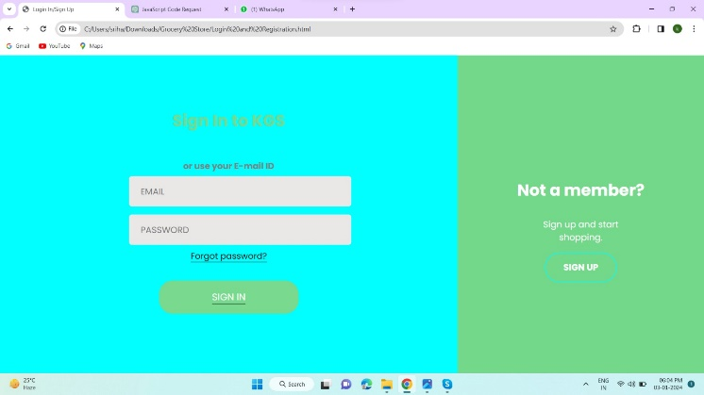search filters or categories, it simplifies the shopping experience by swiftly identifying the aisle or location where the desired products are stocked. This feature saves time, enhances convenience, and provides a seamless navigation experience for customers looking for particular items while shopping online or in-store.By utilizing this tool, customers can plan their shopping trips more efficiently, reduce time spent searching for items, and create smoother shopping experiences. It's an essential feature for modern supermarkets aiming to enhance customer satisfaction and streamline the shopping process.
consumers navigate these expansive spaces is the advent of product finders.E-commerce, short for electronic commerce, revolutionized the way businesses operate by facilitating buying and selling goods or services over the internet. It encompasses a wide range of activities, from online shopping platforms to electronic payments and digital marketing strategies, allowing businesses to reach global audiences, simplify transactions, and create personalized shopping experiences.Certainly! E-commerce operates through various models like Business-to-Consumer (B2C), Business-to-Business (B2B), Consumer-to-Consumer (C2C), and more. It thrives on secure payment gateways, efficient supply chains, and sophisticated data analytics to understand consumer behavior. Key drivers include convenience, accessibility, and the ability to tailor offerings to individual preferences, fostering a dynamic and competitive marketplace. Its continuous evolution involves trends like mobile commerce, AI-driven personalization, and sustainability.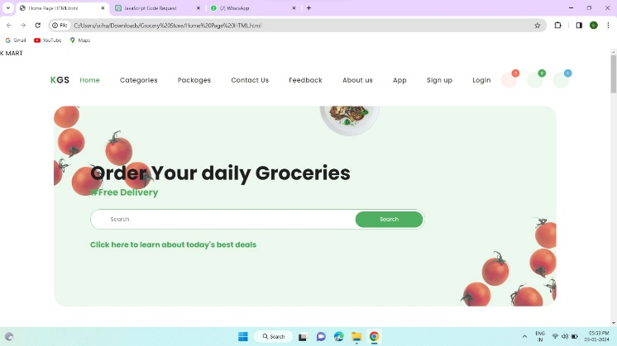
- LITERATURE SURVEY
In the contemporary landscape of retail, supermarkets play a pivotal role in providing an array of products to consumers. With the evolution of technology and changing consumer preferences, the traditional supermarket experience has undergone a significant transformation.
Product finders in supermarkets encompass a range of technological solutions aimed at assisting shoppers in locating specific items within the store premises. Whether through mobile applications, in-store kiosks, or augmented reality interfaces, these tools offer an efficient means for customers to navigate the aisles and swiftly locate desired products. This enhancement not only streamlines the shopping experience but also addresses the challenges posed by the vast assortment of goods available in supermarkets.
This literature survey delves into the multifaceted realm of product finders within supermarket environments. It seeks to explore and synthesize existing research, insights, and empirical studies to comprehensively understand the impact and implications of these technological innovations. By examining the technological implementations, user experiences, consumer behaviors, and the resulting effects on sales and retail performance, this survey aims to provide an in-depth analysis of this emerging trend in the retail landscape.
- EXISTING WORK
Implementing technology in a product finder for supermarkets can significantly enhance the shopping experience. Here are several technological implementations that can be used:

- Mobile Apps:
Store Map Integration: Utilize GPS to guide shoppers to specific aisles or products within the store.
Barcode/QR Code Scanning: Allow users to scan items for pricing, nutritional information, and location within the store.
- Augmented Reality (AR):
AR Navigation: Superimpose directions or markers in real-time on a smartphone's camera view to guide shoppers.
Product Visualization: Enable customers to see product information, reviews, or promotions by pointing their device at items on the shelves.
- RFID Technology:
Smart Shelves: RFID tags on products and smart shelves can automatically update inventory levels and alert staff when restocking is needed.
Checkout-free Systems: Implement systems where RFID tags automatically charge customers upon leaving the store, eliminating the need for traditional checkout.
- Voice Assistants:
In-store AI Assistants: Enable customers to ask questions about product locations, availability, or recommendations using voice commands.
- Machine Learning and Data Analytics:
Personalized Recommendations: Analyze purchase history and behavior to offer personalized suggestions to shoppers.
Inventory Management: Use predictive analytics to optimize stock levels and reduce wastage.
- Online Platforms Integration:
Online-to-Offline (O2O) Integration: Allow customers to reserve items online and pick them up in-store or vice versa.
- PROPOSED WORK
Creating a product finder tool for a supermarket website involves various aspects such as search algorithms, database management, user interface design, and more. As of my last update in early 2022, several approaches were being used or explored by different platforms to enhance product finding experiences on supermarket websites:
Keyword Search: Basic search functionality allowing users to type in the name of the product they're looking for. This can be enhanced with autocomplete and predictive text features.
Category Filters: Dividing products into categories and subcategories (e.g., dairy, fruits, beverages) and allowing users to navigate through these sections to find products.
Visual Search: Allowing users to upload images or use their device's camera to search for products visually. This involves image recognition technology to match uploaded images with available products.
Barcode Scanning: Allowing users to scan product barcodes using their device's camera to find specific items quickly.
Machine Learning and Recommendations: Analyzing user behavior and purchase history to provide personalized
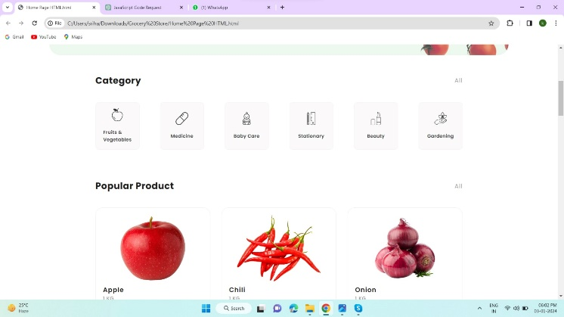recommendations or predict what products a user might be interested in.
Location-Based Services: Providing information about product availability in nearby stores based on the user's location.
Several companies and platforms have developed or integrated these features into their supermarket websites or mobile applications. Amazon, Walmart, Tesco, and various other supermarket chains globally have been investing in improving their product finding experiences.
These solutions require a robust infrastructure, integration with databases of product information, and sometimes partnerships with technology providers specializing in search, image recognition, or recommendation systems.
If you're looking to develop a product finder for a supermarket website, studying these existing approaches can offer insights into what functionalities are effective and how users interact with them. Additionally, collaborating with data management and technology experts might be beneficial to build a successful product finder tool.

FLOW CHART:
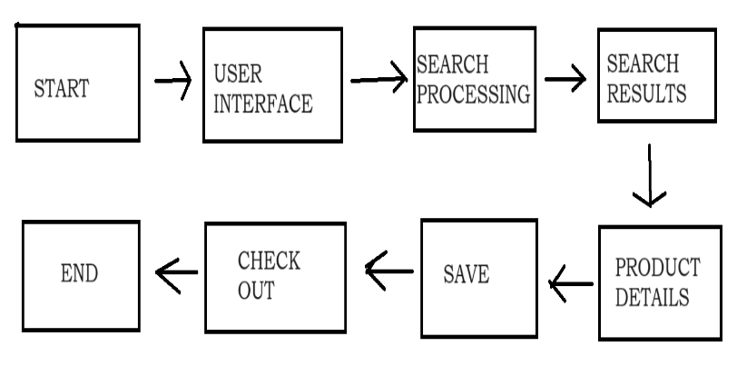
- Define Requirements and Objectives:
  - Identify the main goals of the product finder. Is it to help customers locate products efficiently? Improve customer experience? Increase sales? Or streamline inventory management?
  - Determine the features needed such as search functionality, product categorization, real-time updates, etc.
  - Decide on the platform for deployment: mobile app, website, in-store kiosks, or a combination.
- Market Research:
  - Investigate existing solutions in the market. What features do they offer? How do they address user needs?
  - Analyze customer preferences and pain points through surveys, interviews, or focus groups.
- Data Gathering:
  - Collect data on the supermarket layout, including aisle numbers, shelf arrangements, and product locations.
  - Gather information about the products available in the supermarket, including names, categories, and barcodes.
- Database Design:
  - Design a database schema to store information about the supermarket layout and product details.
  - Consider scalability and efficiency in handling a large volume of data.
- Algorithm Design:
  - Develop algorithms for efficient product search and navigation. This could include algorithms for route optimization within the store.
  - Implement algorithms to update product availability in real-time.
- User Interface Design:
  - Design a user-friendly interface for the product finder application. Ensure it is intuitive and easy to navigate.
  - Include features like voice search, barcode scanning, and filters for narrowing down search results.
- Development:
  - Develop the product finder application using appropriate technologies and programming languages.
  - Implement backend services for data storage, retrieval, and real-time updates.
  - Integrate with external APIs for functionalities like barcode scanning or product information lookup.
- Testing:
  - Conduct thorough testing to ensure the application functions as intended.
  - Test for usability, performance, and reliability.
  - Gather feedback from users and iterate on the design if necessary.
- Deployment:
  - Deploy the product finder application in the chosen platform(s).
  - Ensure it is accessible to customers through various channels, such as app stores or the store's website.
  - Provide training for store staff if needed.
- Maintenance and Updates:
  - Regularly update the product database with new products or changes in the store layout.
  - Monitor performance and address any issues that arise promptly.
  - Incorporate user feedback and continue to improve the application over time.
By following these steps, you can create an effective product finder that enhances the shopping experience for customers in the supermarket.
TOOLS USED:
Software,Hardware,HTML….
- FUTURE SCOPE:
The future scope for a product finder in a supermarket is vast, with advancements in technology and changing consumer behaviors. Here are some potential directions for future development:
- Augmented Reality (AR) Integration:
  - Implement AR features that overlay product information and directions onto the real-world view through a smartphone or AR glasses. This would provide customers with a more immersive and intuitive shopping experience.
- Personalization and Recommendations:
  - Utilize machine learning algorithms to analyze customer purchase history and preferences to offer personalized product recommendations.
  - Provide personalized navigation paths based on past shopping behavior, dietary restrictions, or lifestyle choices.
- Smart Shopping Carts or Baskets:
  - Develop smart shopping carts or baskets equipped with sensors and screens that sync with the product finder app. These devices can guide customers to the items on their shopping list and even suggest complementary products.
- Integration with Smart Home Devices:
  - Enable integration with smart home devices like voice assistants (e.g., Amazon Alexa, Google Assistant) or smart refrigerators. Customers could add items to their shopping list or reorder essentials using voice commands from home.
- Location-Based Offers and Promotions:
  - Integrate beacon technology or geolocation services to send targeted offers and promotions to customers based on their location within the store. This can help drive sales and incentivize purchases.
- Real-Time Inventory Tracking:
  - Enhance the product finder with real-time inventory tracking capabilities. Customers can check the availability of items in-store before visiting or receive notifications when a product they frequently purchase is back in stock.
- In-Store Navigation Assistance:
  - Expand the product finder to provide navigation assistance beyond just locating products. Offer guidance on finding other store amenities like restrooms, checkout counters, or customer service desks.
- Integration with Online Shopping Platforms:
  - Enable seamless integration between the in-store product finder and the supermarket's online shopping platform. Customers could start their shopping journey in-store and seamlessly transition to online ordering for home delivery or curbside pickup.
- Environmental and Social Impact Information:
  - Provide additional product information such as environmental impact (e.g., carbon footprint, sustainability certifications) and social responsibility initiatives (e.g., fair trade, ethical sourcing). This empowers customers to make more informed purchasing decisions.
- Feedback and Analytics:
  - Gather data on customer interactions with the product finder to gain insights into shopping behaviors and preferences. Use this data to continually refine the user experience and optimize store layout and product placement.
By embracing these future trends and technologies, a product finder in a supermarket can evolve to meet the changing needs and expectations of customers, ultimately enhancing the overall shopping experience and driving business growth.

- CONCLUSION
A concluding summary for a product finder in a supermarket project could emphasize the following points:

Enhanced Shopping Experience: The product finder has significantly improved the shopping experience for customers by providing a convenient way to locate items within the store. It has reduced search time and increased overall satisfaction.

Efficiency and Time-Saving: With the implementation of the product finder, customers spend less time wandering aisles and searching for items, leading to increased efficiency during their shopping trips. This efficiency benefits both customers and the market, improving overall operations.

Increased Sales and Customer Loyalty: By facilitating easy navigation and helping customers find what they need quickly, the product finder has likely contributed to increased sales and encouraged repeat visits. Satisfied customers are more likely to return and recommend the store to others.

Adaptability and Scalability: The project's success demonstrates the adaptability of technology within retail environments. The implementation of a product finder can be scaled or customized for various supermarket chains or even other retail sectors to enhance customer experience.

Future Improvements: Continuous improvement is crucial. Feedback from customers and store staff can be used to refine the product finder further. Integration with mobile apps or additional features like personalized shopping lists could be explored to add more value.

Overall, the product finder has proven to be an invaluable addition to the supermarket, aligning with the goal of providing a seamless and efficient shopping experience for customers. Its success sets a precedent for technological integration in retail spaces, benefitting both customers and the market itself.
- REFERENCES:
1.Spassova, L., Kahl, G., Krüger, A.: user-adaptive Advertisement in Retail Environments. In: Proceedings of the 3rd Workshop on Pervasive Advertising and Shopping, helsinki, Finland (2010).
2. Butz, A., Schneider, M., Spassova, M.: SearchLight – A Lightweight Search Function for Pervasive Environments. In Pervasive. (2004) 351–356.
3. Chun, M. M., Wolfe, J. M. Visual Attention. In B. Goldstein (Ed.), Blackwell Handbook of Perception (pp. 272-310). Oxford, UK: Blackwell Publishers Ltd (2001).
4. Downs, R. M., and Stea, D. Cognitive Maps and Spatial Behaviour: Process and Products. John Wiley & Sons, Ltd, Chichester, UK, Apr. 2011
5. Metaio: http://www.metaio.com6. Kalnikaite, V., Rogers, Y., Bird, J., Villar, N., Bachour, K., Payne, S., Todd, P.M., Schöning, J., Krüger, A., Kreitmayer, S.: How to nudge in Situ: designing lambent devices to deliver salient information in supermarkets. In Proceedings of the 13th international conference on Ubiquitous computing (UbiComp ’11). ACM, New York, NY, USA, 11-20.
7. IBM Augmented Reality Shopping App: http://www.research.ibm.com/articles/augmented-reality.shtml
8. Posner, M. I., Snyder, C. R., Davidson, B. J. (1980). Attention and the detection of signals., Journal of Experimental Psychology: General, 109, 160-174
9. Kahl, G., Spassova, L., Schöning, J., Gehring, S., Krüger, A.: IRL SmartCart - a user-adaptive context-aware interface for shopping assistance. In Proceedings of the 16th international conference on Intelligent user interfaces (IUI ’11). (2011) ACM, New York, NY, USA, 359-362.
10.Black, D., Clemmensen, N., Skov, M.: Shopping in the Real World: Interacting with a Context-Aware Shopping Trolley. In Proc. of MobileHCI ’09 : Workshop on Mobile Interaction with the Real World, September 2009.
11.Schwerdtfeger, B., Reif, R., Gunthner, W.A., Klinker, Gudrun, Hamacher, D., Schega, L., Böckelmann, I., Doil, F., Tumler, J.: Pick-by-Vision: A first stress test. Mixed and Augmented Reality, 2009. ISMAR 2009. 8th IEEE International Symposium on , vol., no., pp.115,124, 19-22 Oct. 2009 doi: 10.1109/ISMAR.2009.5336484
12.Löchtefeld, M., Gehring, S., Schöning, J., Krüger, A.: ShelfTorchlight: Augmenting a Shelf using a Camera Projector Unit. Adjunct Proceedings of the Eighth International Conference on Pervasive Computing, Helsinki, Finland, Springer Lecture

